**2017 International Day of Persons with Disabilities**

UN Headquarters, Conference Room 4

Friday, 1 December 2017

Organized by DESA,

Co-sponsors: Antigua and Barbuda, Bulgaria, Ecuador, Germany, Italy, Japan, New Zealand, Republic of Korea, San Marino, European Union, NGO Committee on Ageing

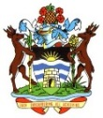C:\Users\Xing.Lu\AppData\Local\Microsoft\Windows\Temporary Internet Files\Content.Word\COA  NZ Crest HQ.TIFF****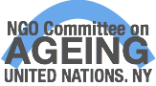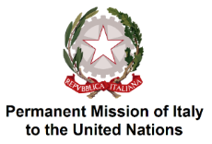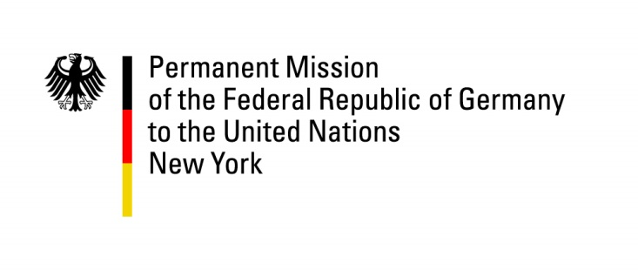

**PROGRAMME**

**Theme: Transformation towards sustainable and resilient society for all**

***09.00 to 10.00 – Heidi Latsky Dance Installation, Visitors’ Entrance***

***09.55 to 10.00 – Introduction of the Opening Session by Ms. Daniela Bas, Director, DSPD/DESA***

***10.00 to 11.10 – Opening Session***

First segment:

* Moderator: Ms. Venus Ilagan, Secretary General, Rehabilitation International
* H.E. Mr. Miroslav Lajčák, Presidentof the 72nd session of the General Assembly
* H.E. Ambassador Mr. Georgi Panayotov, Permanent Representative of Bulgaria
* H.E. Mr. Finnian Cheshire, Deputy Permanent Representative of New Zealand

Second segment:

* Moderator: Ms. Venus Ilagan, Secretary General, Rehabilitation International
* H.E. Ambassador Mr. Feridun H. Sinirlioğlu, Permanent Representative of Turkey
* H.E. Ambassador Mr. Diego Morejón-Pazmiño, Permanent Representative of Ecuador
* H.E. Ambassador Mr. Toshiya Hoshino, Deputy Permanent Representative of Japan
* H.E. Ambassador Mr. Park Chull-joo, Deputy Permanent Representative of Republic of Korea
* Ms. Penny Hartin, Chief Executive Officer, World Blind Union

***11.10 to 11.16 – Screening of the short film on promoting school transport for children with disabilities from Access Exchange International***

***11.17- 11.20 – Introduction of musical performance and Mr. Bae Boumjun by Ms. Daniela Bas, Director, DSPD/DESA***

***11.20 to 11.35 – Performance by Korean musicians and statement by Mr. Bae Boumjun***

***11. 35 to 11.40 – Screening of two short films “Include Us”, and “Message of Life”***

***11. 40 to 11.45 – Introduction of panel discussion by Ms. Daniela Bas, Director, DSPD/DESA***

***11.45 a.m. to 1.00 p.m. Panel Discussion on “Persons with disabilities as agents of change: Lessons from disability-inclusive disaster risk reduction and humanitarian action for resilient and sustainable societies”***

* Moderator: H.E. Ambassador Mr. Luis Gallegos, Special Advisor, Nippon Foundation
* Ms. Margaret Arnold, Senior Social Development Specialist, Social, Urban, Rural and Resilience, World Bank
* Mr. Gopal Mitra, Programme Specialist - Children with Disabilities, Disability Section/Programme Division, UNICEF
* Mr. Hiroshi Kawamura, Board Member and Former President of the DAISY Consortium
* Mr. Satoshi IIyama, Co-Founder, University of Tokyo Empower Project
* Ms. Boram Lee, Disability Advisor, Women’s Refugee Commission
* Mr. Victor Pineda, President of GAATES and World Enabled (per video)

***12. 55 p.m. to 01.00 p.m. – Screening of the video “Medea” from Teatro Patologico***

***1.15 p.m. – 2.30 p.m. – Side event on “Big data analytics and text mining: monitoring and evaluating disability and development for SDGs and CRPD implementation”, Conference Room A***

***1.15 p.m. – 2.30 p.m. – Side event on “Sustainable developments in health through innovative technologies”, Conference Room 8***

***3.00 p.m. to 6.00 p.m. Panel Discussion on “Building Future Societies for All”***

Opening remarks

* H.E. Ambassador Ms. Joanne Adamson, Deputy Head of European Union Delegation
* H.E. Ambassador Mr. Georgi Velikov Panayotov, Permanent Representative of Bulgaria
* H.E. Ambassador Mr. Damiano Beleffi, Permanent Representative of San Marino
* Mr. Kazi Rahman, Deputy Special Representative, United Nations World Tourism Organization NY Liaison Office

Panel A

* Moderator: Dennis Anderson, Chairman, Center for Entrepreneurship, Institute of E-Government and Sustainability, St. Francis College
* H.E. Ambassador Ms. Helena Yánez Loza, Deputy Permanent Representative of Ecuador
* Mr. Victor Calise, Commissioner, New York City Mayor’s Office for People with Disabilities
* Mr. John Farmer, Director, Microsoft Cities
* Ms. Lauren Gula, Senior Manager, Social Responsibility and Gender Equality, UN Global Compact
* Mr. Srin Madipalli, Accessibility Program and Product Manager, AirBnB
* Mr. Rick Chavolla, American Indian Community House

Panel B

* Moderator: Ahmed Fathi, Managing Editor, American Television News
* H.E. Ambassador Mr. Walton Alfonso Webson, Permanent Representative of Antigua and Barbuda
* Mr. Bryan Grimaldi, Chief Operating Officer and General Counsel, NYC & Company
* Ms. Daniella Foster, Senior Director of Global Corporate Responsibility, Hilton Worldwide
* Mr. Clark Stevens, Director of Government Affairs and Strategic Partnerships, AirBnB
* Ms. Tui Shortland, Co-Founder, Native XP
* Ms. Lynn Minnaert, Academic Chair, Jonathan M. Tisch Center for Hospitality and Tourism, New York University

